PROJECT

RFID door lock Using ARDUINO UNO

RFID stands for Radio Frequency IDentification and it’s a non-contact technology that’s broadly used in many industries for tasks such as personnel tracking, access control, supply chain management, books tracking in libraries, tollgate systems and so on.

Circuit and Working

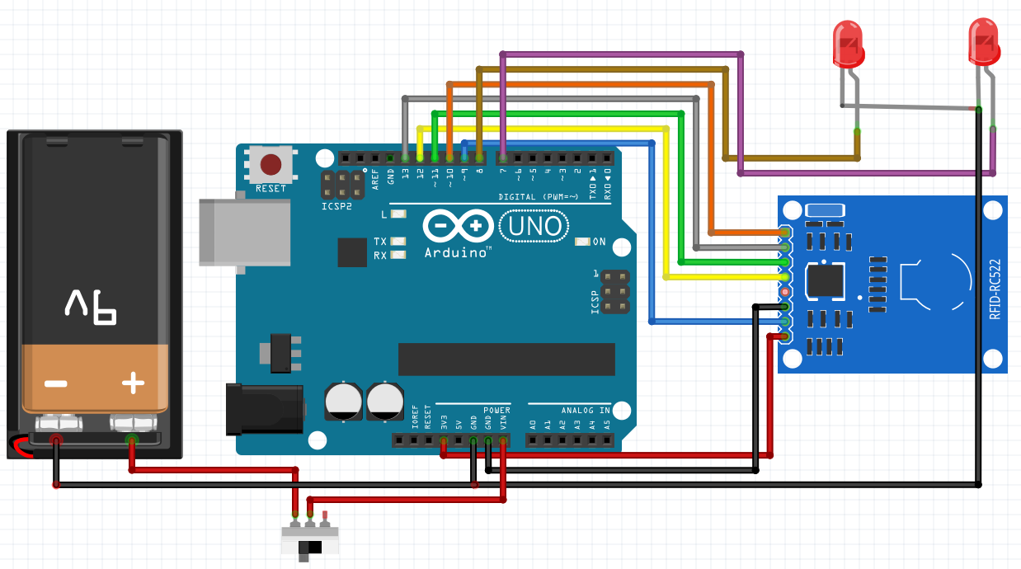

PIN CONNECTIONS

SDA is connected to pin 10 ,SCK is connected to pin 13, 3.3v connected to 3.3v arduino , GND to GND ,MOSI connected to 11 pin , MISO connected to pin 12 ,positive end of battery is connected to 1st pin of switch , 2nd pin of switch is connectes to VIN , negative leg of 1st led is connected to 8,7

WORKING

An RFID system consists of two main components, a transponder or a tag which is located on the object that we want to be identified, and a transceiver or a reader. The RFID reader consist of a radio frequency module, a control unit and an antenna coil which generates high frequency electromagnetic field. On the other hand, the tag is usually a passive component, which consist of just an antenna and an electronic microchip, so when it gets near the electromagnetic field of the transceiver, due to induction, a voltage is generated in its antenna coil and this voltage serves as power for the microchip.

Now as the tag is powered it can extract the transmitted message from the reader, and for sending message back to the reader, it uses a technique called load manipulation. Switching on and off a load at the antenna of the tag will affect the power consumption of the reader’s antenna which can be measured as voltage drop. This changes in the voltage will be captured as ones and zeros and that’s the way the data is transferred from the tag to the reader.

CODE

#include <SPI.h>

#include <MFRC522.h>

MFRC522 mfrc522(10, 9);

int granted = 8;

int denied = 7;

void setup(){

Serial.begin(9600);

SPI.begin();

mfrc522.PCD_Init();

pinMode(granted,OUTPUT);

pinMode(denied,OUTPUT);

Serial.println("Place the Card or Tag ");

}

void loop(){

if ( ! mfrc522.PICC_IsNewCardPresent()){

return;

}

if ( ! mfrc522.PICC_ReadCardSerial()) {

return;

}

Serial.print("Tag: ");

String content= "";

for (byte i = 0; i < mfrc522.uid.size; i++) {

Serial.print(mfrc522.uid.uidByte[i] < 0x10 ? " 0" : " ");

Serial.print(mfrc522.uid.uidByte[i], HEX);

content.concat(String(mfrc522.uid.uidByte[i] < 0x10 ? " 0" : " "));

content.concat(String(mfrc522.uid.uidByte[i], HEX));

}

Serial.println();

content.toUpperCase();

content = content.substring(1);

if(content == "56 E0 67 AC"){

digitalWrite(granted,HIGH);

digitalWrite(denied,LOW);

Serial.println("Access Granted.");

Serial.println();

delay(900);

}else{

digitalWrite(granted,LOW);

digitalWrite(denied,HIGH);

Serial.println("Access Denied.");

delay(900);

}

}}

